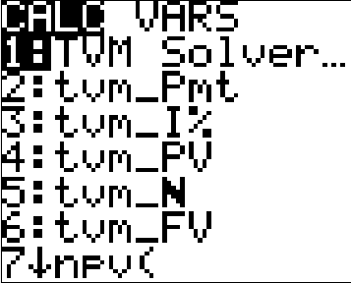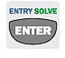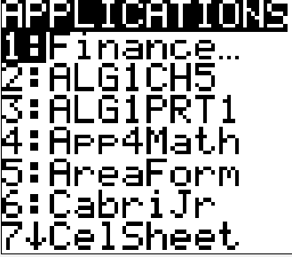**How to access**: Press

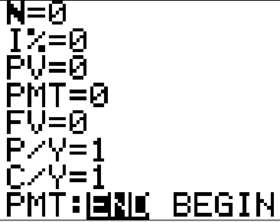**N**: Total number of payment periods over the investment or loan.  
(number of payments per year) × (number of years)  
Ex: For 30-year investment with monthly compounding, N=30∙12=360

**I%**: Annual interest rate (APR as *percent*, not as a decimal).  
Ex: Enter 9.5 instead of .095 for 9.5%

**PV**: Present value. Your present value (principal, deposit) of your investment or the current mortgage balance.

**PMT**: The payment amount of the loan or the amount you are contributing to the investment.

**FV**: Future value. Your balance of the investment or loan after **N** payment periods. (Acts like the variable *A* in interest formulas)

*For the problems we will do for class,* ***P/Y*** *and* ***C/Y*** *will be the same.*

**P/Y**: number of payment periods per year.

**C/Y**: number of compounding periods per year.

**PMT**: Always keep **END** highlighted.

**IMPORTANT NOTES:**

* You will enter values for every variable but one, and then you will solve for the remaining variable by using   
  on the row that you are trying to calculate.
* There must be a number in each field. If you press “CLEAR,” you will not be able to leave that field until you enter another number in that field.
* For investments, FV and PV will have *opposite* signs – if one is negative, the other must be positive.
* The TVM Solver should **NOT** be used for **simple interest** calculations!!

1. **Lump-Sum Investment  
   (find the Future Value)**

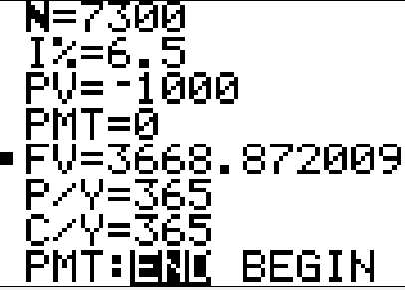You deposit $1000 in an account that bears 6.5% interest compounded daily for 20 years. How much will this investment be worth at the end of the 20 years?

A “deposit” is something you “pay” into, so it’s negative.

Enter 365*20





**The investment will be worth $3668.87 in 20 years.**

1. **Lump-Sum Investment  
   (find the Present Value)**

You want to accumulate $7500 over the next 15 years by making a single deposit into a savings account now. How much deposit do you need to invest in order to reach your goal if you find a savings account with 4.5% interest compounded continuously?

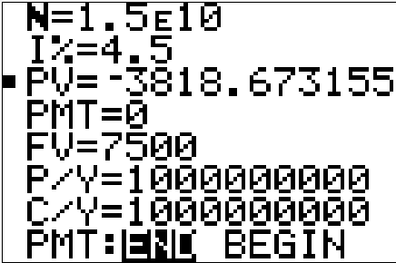**Note**: for continuous compounding, use a VERY large number for compoundings, such as 1,000,000,000.

Enter 1000000000 * 15

**You need to deposit $3818.67 in order to meet your goal.**

1. **Find the annual percentage rate (APR) – with finance charge**

Find the annual percentage rate for $4700 financed, with a finance charge of $1002, and a loan term of 36 months.

This is a little bit more work. First, we need to calculate the ***monthly payment*** (PMT):

$$-\frac{Amount Financed+Finance Charge}{Total months of the Loan}$$

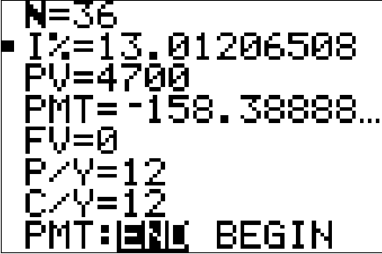So, in this example, for the **PMT=** line, you would type -(4700+1002)/36

Payments are made monthly.

**The APR for this loan (rounded to the nearest half-percent), would be 13%.**

1. **Find the APR (annual percentage rate) – with add-on interest rate**

Find the annual percentage rate (true annual interest rate), to the nearest half-percent, for a loan with purchase price of $4220, down payment of $380, add-on interest rate 5%, with 12 monthly payments.

Amount financed = Purchase Price – Down Payment  
 = 4220 – 380 = $3840 (PV)

Again, this is a bit more work. **Add-on interest rate** allows you to determine the ***finance charge***. Use the Simple Interest Formula (*I* = *P r t*) to get the finance charge (remember *t* is in years, not months):

Finance charge = 3840 × .05 × 1 = $192

**4. Find the APR (annual percentage rate) – with add-on interest rate (cont’d)**

So monthly payment (**PMT**) would be:

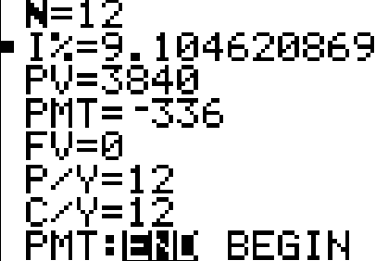So for the **PMT**= line, you would type  
 -(3840+192)/12

**The APR for this loan, rounded to the nearest half-percent, is 9%.**

1. **Find the Finance Charge and APR for a loan**

The cash price for a fitness system is $659.99. The customer paid $115 as a down payment. The remainder will be paid in 36 monthly installments of $19.16 each. Find the amount of the finance charge and the APR for the loan.

To get the finance charge, you do not need to use TVM Solver yet.   
Purchase Price – Down Payment = Amount Financed  
659.99 – 115 = $544.99 = Amount Financed (PV)

Monthly Payment × Number of Payments = Total Paid Back  
19.16 × 36 = $689.76 = Total Paid Back

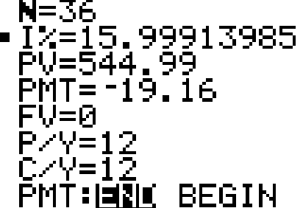Total Paid Back – Amount Financed = Finance Charge  
689.76 – 544.99 = **$144.77 = Finance Charge**

**The APR on this loan is about 16%.**

1. **Finding a monthly mortgage payment – basic**

Find the monthly payment on a loan of $97,000 at 5% for 10 years.

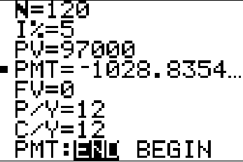



**The monthly payment is $1028.84.**

1. **Finding a monthly mortgage payment – with taxes and insurance**

Find the total monthly payment, including taxes and insurance, on the following fixed-rate mortgage: Amount of Loan = $66,300, Interest Rate = 10%, Term of Loan = 15 years, Annual Taxes = $607, Annual Insurance = $334.

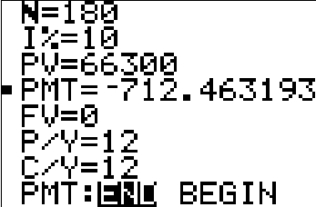First, calculate the mortgage payment *before* the taxes and insurance are considered:



Next, add together the annual taxes and insurance:

607 + 334 = $941 ÷ 12 ≈ $78.42 per month for taxes and insurance.

Finally, add this amount to the monthly mortgage payment you got from TVM Solver:

$712.46 + $78.42 = $790.88

**The total monthly payment, including taxes and insurance, is $790.88.**